Student’s name | …………………………………………………….…… | Grade | 1
Subject | Computer | Week No. | 11
Lesson Title | A Digital Notepad | Unit
Worksheet No. ( 11 )

Question A: write the correct name of each part

Keyboard | Notepad | Enter | Space
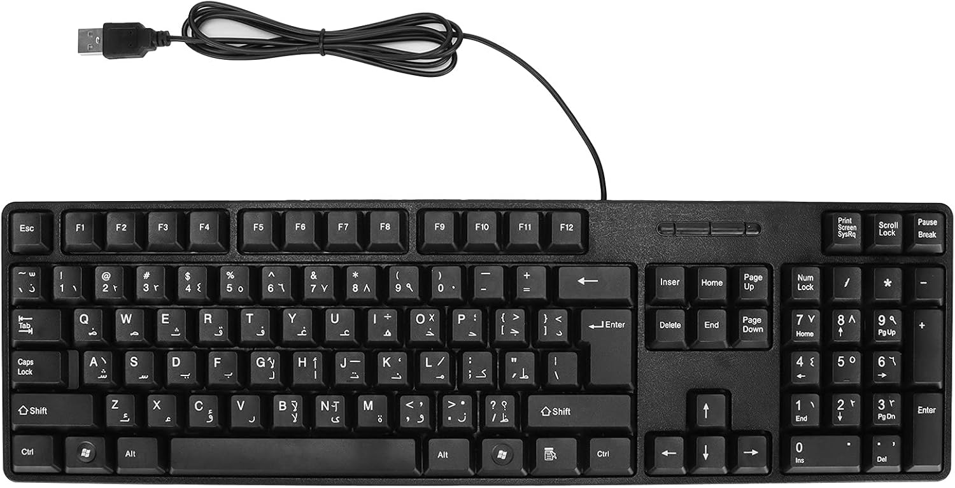

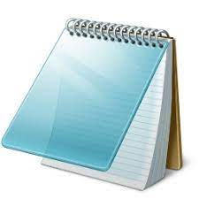

Good Luck

